Outline:

Draw on palm of hand “HI”, other “C#”

Intro like ‘The General‘ silent movie (need animation to make it flicker)

http://www.bing.com/videos/search?q=the+general+youtube&FORM=VIRE1#view=detail&mid=99BE8CBE9D9E82F1A65899BE8CBE9D9E82F1A658

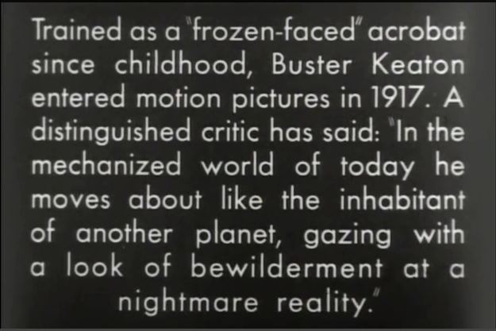

Train chugging along

SignalR – “Sign” – my kind of language!

Show diagram with database:

Client -- Server – database

Polling, let’s try to see what it looks like and see CPU time goes up.

New way, hit db once, then SignalR for the rest.

Demo (need database with server log messages)

Something polling

Showing messages up every 1 second

Let’s change to SignalR

(server log messages)

No more polling, but need to query database to get historical info

Showing messages faster than 1 second!

Show things using Toastr from CodeSeven -- <http://codeseven.github.io/toastr/>

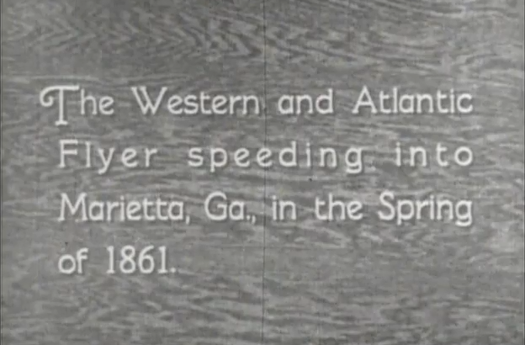

Show IronPython calling hub

Show PowerShell script calling hub

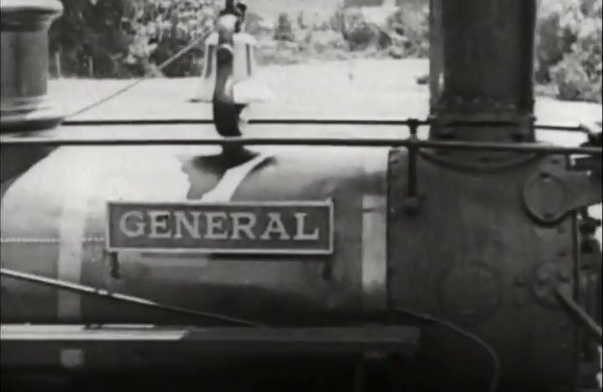

Why would you use SignalR?

* Database stressed out due to polling

[Show diagram]

* Informing your customers of something right away

[Show web page with Toastr]

* Immediate feedback on something you’re doing

[Show ‘em VS 2013 and edit a page?]

What is SignalR?

TL;DR: Web sockets that we get in node.js. Live baseball strikes and balls when you watch a game (no radio, Deaf!!)

[Screenshot of mobile game]

Long line!

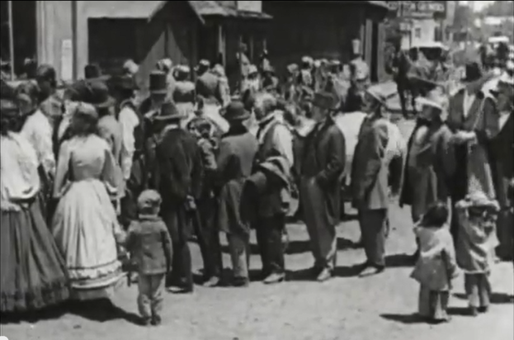

Get rid of it with SignalR!

Management:

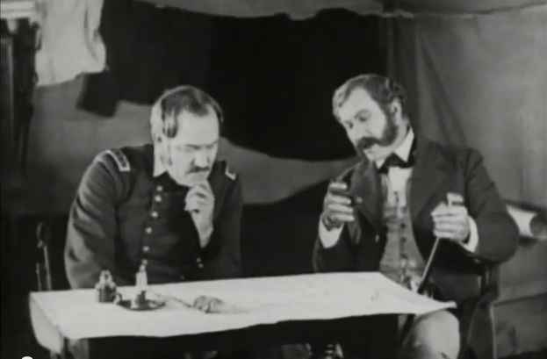

The queue:

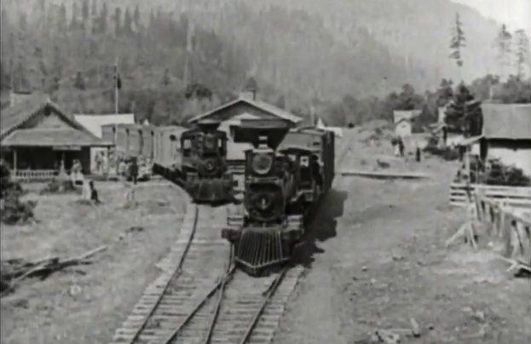

Roadblocks:



And the chase is on!

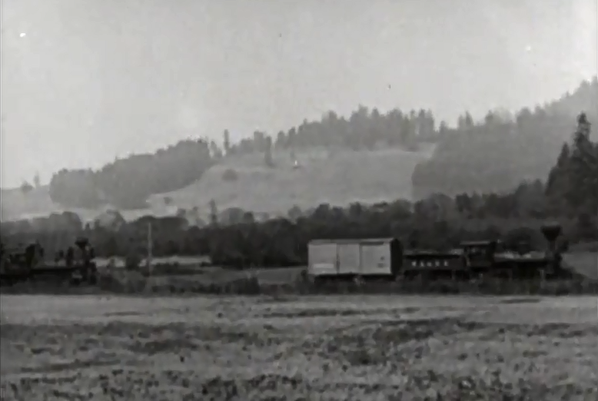

Hero! Got a parade --

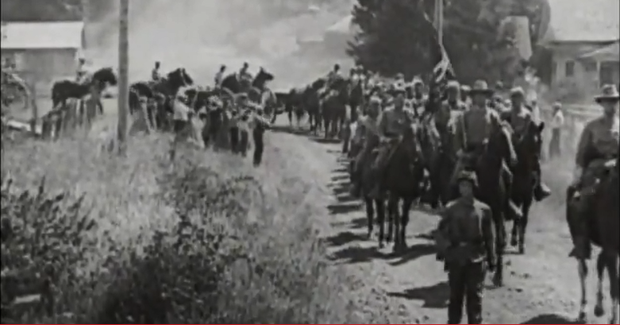

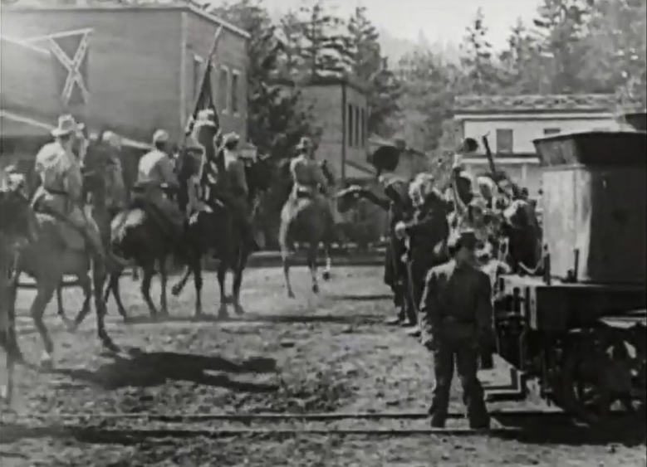

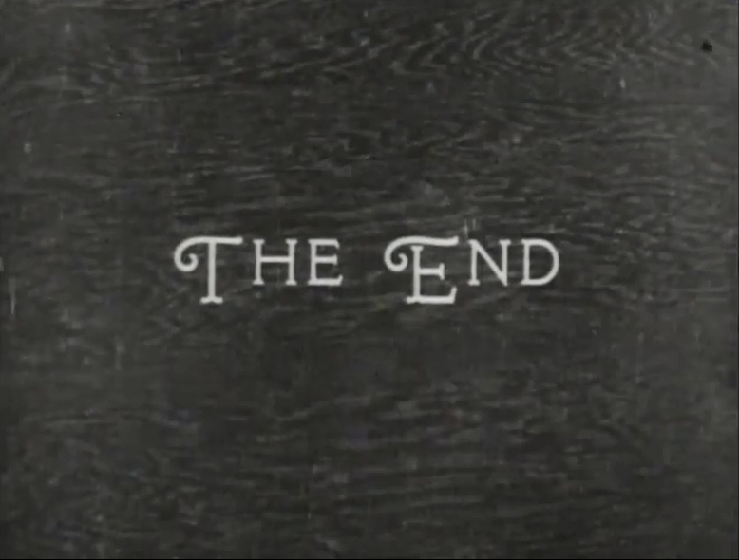

Thanks to my wife Wendy, Pami Sherwin [MHF], Crystal Long [Microsoft Access MVP], Dawn Heep [MHF] for the support!

MUST SEE: Brady Gaster’s SignalR presentation at MSIgnite: “Why should the web pages have all the real-time fun!”

http://channel9.msdn.com/Events/Ignite/2015/BRK3728